7COM1079-0901-2025 - TEAM RESEARCH AND DEVELOPMENT PROJECT

Final report title: Transportation Fuels Inventory: Beginning 2004
Group ID: B 109
Dataset number: DS037

PRESENTED BY: Quadri Oyebola 23099062
Inturi Venkata Sambasivarao 23101452
Leelavaraprasad Singamsetti 23099866
Gopu Anuroop Reddy 23099124
Thayalan Senthalan 23100783

University of Hertfordshire
Hatfield, 2025

1. Introduction

1.1 Problem statement and research motivation

To predict changes in energy markets, it's important to know how different parts of the fuel supply chain work together. Specifically, determining whether fluctuations in U.S. crude oil stocks affect petrol inventories can yield insights into production strategies, storage regulations, and price instability. Earlier research shows that the amount of crude oil available and the amount of petrol produced at refineries are two of the most important factors that affect petrol supply (Kaufmann & Ullman, 2009). But in the real world, inventory patterns change because of seasonal demand and the economy, which shows that more statistical research is needed. This study seeks to enhance comprehension of the correlation between crude oil and petrol inventories through the analysis of historical U.S. fuel inventory data.

1.2 The data set

The dataset shows how much crude oil and finished petrol the U.S had in stock each week, measured in thousands of barrels. It covers several years and comes from national records of transportation fuel inventories. The variables of interest for this study are crude oil and petrol stocks. The dataset allows for the examination of long-term supply trends and variability within the petroleum sector and is appropriate for statistical correlation analysis because of its size and continuous numeric values.

1.3 Research question

Is there a correlation between fuel production volume and fuel inventory levels in the United States?
This study examines the potential statistical correlation between U.S. crude oil inventory levels and U.S. petrol inventory levels. The aim is to ascertain whether rises in crude oil inventories are typically associated with rises in petrol inventories, thereby elucidating the supply-chain dynamics between crude oil availability and petrol production.

1.4 Null hypothesis and alternative hypothesis

To tackle the research question, hypotheses were formulated under the premise of a linear correlation between crude oil and petrol inventories.
- H₀ (Null hypothesis): There is no correlation between U.S. crude oil stocks and U.S. gasoline stocks. Any observed relationship is due to random variation.
- H₁ (Alternative hypothesis): There is a correlation between U.S. crude oil stocks and U.S. gasoline stocks.
By using Pearson's correlation to test these hypotheses, you can find out if there is a statistically significant linear relationship between the variables.

2. Background Research

2.1 Research papers

Previous research has investigated the correlation between crude oil availability and refined fuel production, emphasising the interdependence of upstream and downstream petroleum markets. Kaufmann and Ullman (2009) examined the impact of crude oil inventories on petrol production and determined that refinery output capacity closely mirrors variations in crude supply, particularly during times of heightened demand. In a similar study, Kilian (2016) looked at global oil supply shocks and found that changes in the availability of crude oil have a direct impact on fuel inventories and prices along the production chain. This shows how important it is to keep track of inventories for market forecasting. Baumeister and Kilian (2017) also looked at how fuel is stored and showed that refinery decisions, crude oil input volumes, and economic expectations have a big effect on petrol inventories. While these papers did not utilise the precise dataset used in this project, they employed analogous U.S. energy stock and refinery datasets from national petroleum statistics, thereby offering robust theoretical support for this investigation. In general, the research consistently supports the idea that crude oil inventories are a major factor in determining the availability of fuel downstream. However, the strength and consistency of the statistical relationship over long periods of time still need to be proven through experiments.

2.2 Why RQ is of interest

The research question is significant due to the extensive examination of oil markets, yet insufficient attention has been directed towards quantifying the correlation between U.S. crude oil stocks and petrol inventories using long-term historical data. The majority of literature focusses on price mechanisms or supply shocks instead of inventory relationships. Knowing if the two stock levels move together is important for figuring out when fuel will be available, planning refinery schedules, and managing risk during supply disruptions. This study uses statistical correlation analysis on weekly inventory data to fill a gap in the literature and give policymakers, refinery planners, and market analysts useful information.

3. Visualisation

3.1 Appropriate graphs for the RQ

The main plot shows a scatterplot of U.S. petrol stocks and U.S. crude oil stocks, along with a fitted regression line and confidence band. This is a good way to look at a linear relationship between two continuous variables. There are also histograms for each variable to look at their distributions and see if they are good for correlation.
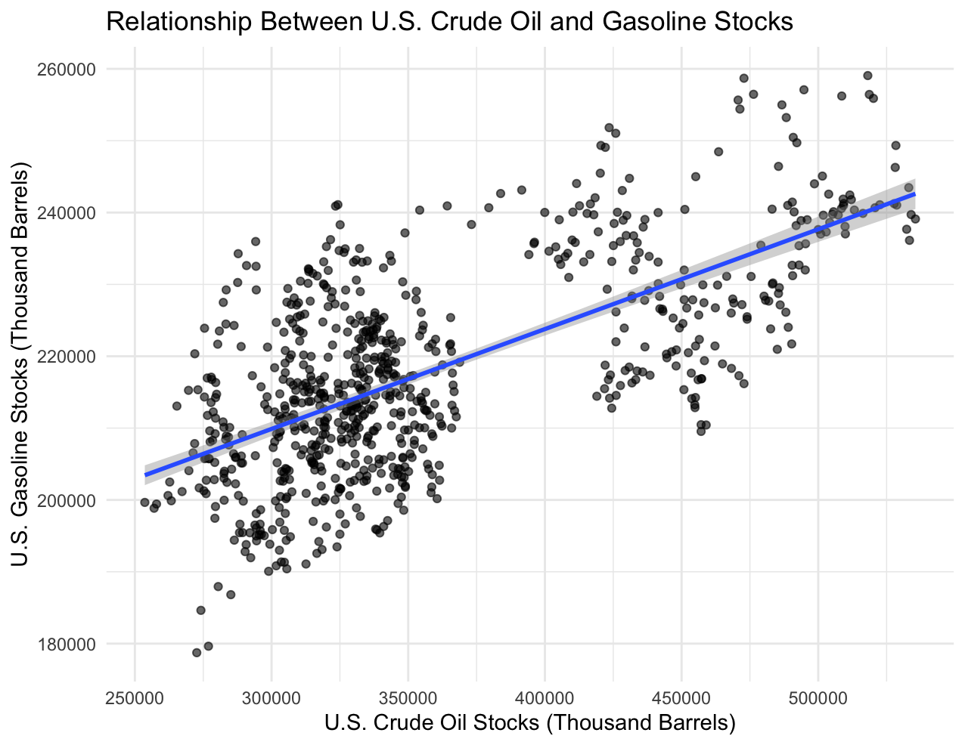
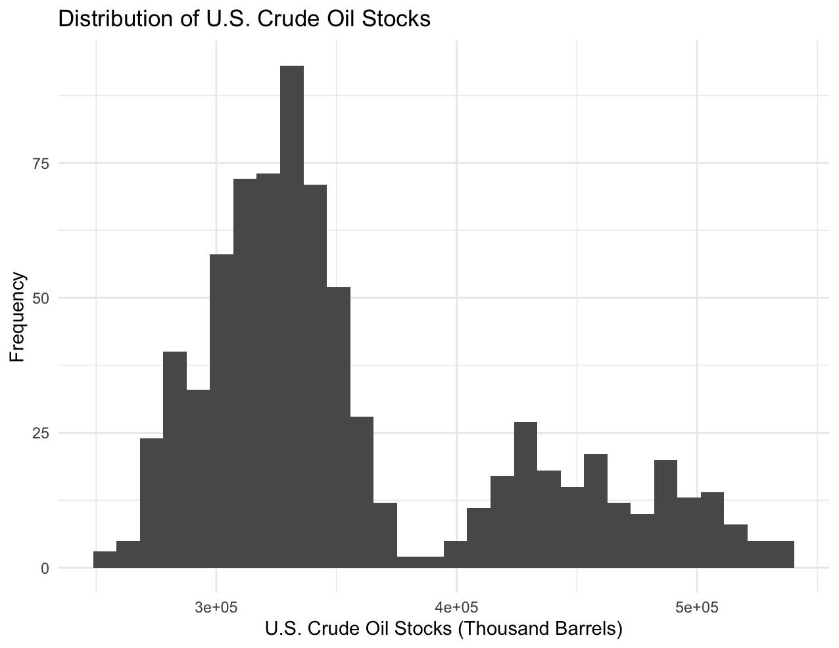
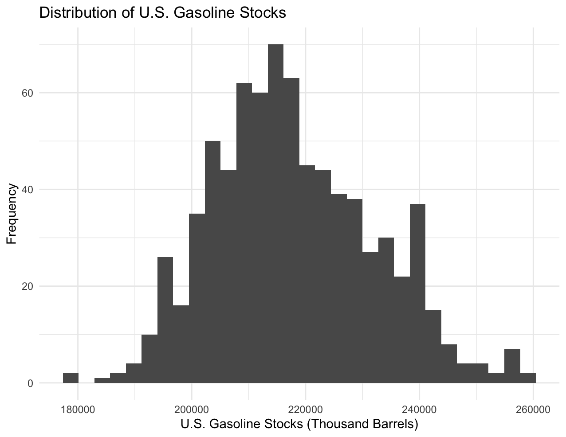

3.2 Additional information relating to understanding the data

The scatterplot shows that most of the data points are grouped together along an upward-sloping trend. This suggests that there is a positive link between crude oil and petrol inventories. The histograms show that gasoline stocks are distributed in a way that is roughly symmetric, while crude oil stocks have a multi-modal structure, which means that there are times when the inventory regimes are very different from each other.

3.3 Useful information for data understanding

In general, when crude oil stocks are higher, petrol stocks also increase. This supports the idea that refiners turn crude oil into petrol in a fairly consistent way. The points that are spread out around the regression line show natural variation caused by factors like seasonal demand, refinery capacity, and the overall state of the market.

4. Analysis

4.1 Statistical test used to test the hypotheses and output

A Pearson product-moment correlation test was used to see if there was a linear relationship between U.S. crude oil stocks and U.S. petrol stocks. This test is suitable because both variables are continuous, assessed on an interval scale, and approximately normally distributed, as evidenced by their histograms. The test yielded a correlation coefficient of r = 0.6619, accompanied by a 95% confidence interval ranging from 0.6202 to 0.6998 and a p-value < 2.2 × 10⁻¹⁶, signifying a highly significant outcome.
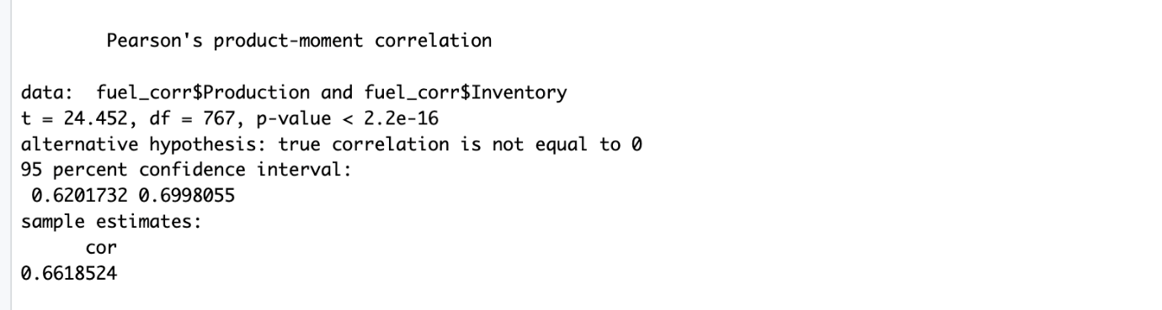

4.2 Interpretation of hypothesis test

The null hypothesis (H₀) is rejected in favour of the alternative hypothesis (H₁) because the p-value is much lower than the standard significance threshold of 0.05. The results show that there is a strong statistical link between U.S. crude oil stocks and U.S. petrol stocks. Over time, this means that when crude oil inventories go up, petrol inventories also go up. Correlation does not demonstrate causation; however, the robustness and consistency of the relationship indicate that crude oil availability significantly influences petrol storage levels, likely influenced by refinery processing and market demand dynamics.

5. Evaluation – Group’s Experience at 7COM1079

5.1 What went well

When we had to make analytical decisions, our group worked well together and we ensured there was, constant communication to achieve a common goal. By giving each member a specific task, we were able to finish cleaning the dataset, making R visualisations, and doing statistical tests on time. The analysis phase went well because we all agreed on the research question and the statistical method early on. Sharing work and keeping track of progress on GitHub cut down on work duplication and let members review and improve each other's work.

5.2 Points for improvement

The project went well overall, but there were times when the workload wasn't evenly distributed, especially close to the deadline. Some members had to put in extra time to finish editing and citing, which could have been avoided if progress checks had been done earlier. We also had some trouble merging code updates in GitHub because of version conflicts. More consistent early documentation of decisions would help keep everyone on the same page and avoid having to do work again.

5.3 Group’s time management

Overall, time management was good, and early goals were reached as planned. But a lot of the report writing happened in the last week, which made things even more stressful. A more organised weekly progress plan and starting documentation and evaluation tasks earlier would help future projects use their time better.

5.4 Project’s overall judgement

The project met its goals and answered the research question by using visualisation and statistical analysis. Everyone worked on important tasks, and the results were in line with what the module was supposed to teach. The group learnt how to work together, analyse data, program in R, and write academic papers.

5.5 Comment on GitHub log output

The GitHub log output (see Appendix B) shows that group members made regular contributions to the project over time. The commit history shows that people worked together instead of alone, and it shows how data cleaning, visualisations, and report writing got better over time.

Git Command | Broader Impact
git commit -m "Cleaned dataset and removed duplicate rows" | Ensured data accuracy and established a reliable foundation for all later visualisations and statistical tests.
git commit -m "Added scatterplot and histograms with regression line" | Delivered the core visual evidence used for analysing the research question and interpreting the correlation.
git commit -m "Inserted statistical test results and conclusions in report" | Linked quantitative output with academic discussion, enabling completion of the main analytical contribution of the project.

6. Conclusions

6.1 Results explained

The Pearson correlation test showed a statistically significant positive relationship between U.S. crude oil stocks and U.S. gasoline stocks. The correlation coefficient was 0.6619 and the p-value was less than 2.2 × 10⁻¹⁶. This means that during the time period studied, higher levels of crude oil inventory usually meant higher levels of petrol inventory. The visualisations back this up by showing a clear upward trend in the scatterplot and well-distributed histograms.

6.2 Interpretation of the results

These results imply that heightened crude oil availability significantly affects petrol stock levels, aligning with the notion that increased crude input allows refineries to sustain or augment petrol production. The findings substantiate a significant, practical correlation between the two categories of fuel inventories in relation to the research question. This relationship shows that problems with crude oil supply can directly affect petrol storage, availability, and market stability across the industry.

6.3 Future work and study limitations

Future research may incorporate seasonal adjustments, additional refined fuel types, or the effects of refinery utilisation rates to enhance the comprehension of inventory dynamics. A limitation of this study is that correlation does not imply causation, and other economic or operational factors may also contribute to observed fluctuations in inventory levels.

7. Reference

Baumeister, C. & Kilian, L. (2017). Understanding the decline in the price of oil since June 2014. Journal of the Association of Environmental and Resource Economists, 4(1), pp. 131–158.
Kaufmann, R.K. & Ullman, B. (2009) Oil prices, speculation, and fundamentals: Interpreting causality in the inventory–price relationship. Energy Economics, 31(4), pp. 550–558.
Kilian, L. (2016). The impact of global oil supply shocks on the U.S. economy. The Energy Journal, 37(2), pp. 1–32.
U.S. Energy Information Administration (EIA). (2019) Weekly U.S. ending stocks of crude oil and gasoline. Available at: https://www.eia.gov/ (Accessed: [28/11/2025]).

8. Appendix section

8A. R code used for analysis and visualisation
library(ggplot2)
library(dplyr)
fuel_corr <- fuel %>%
transmute(
Production = `U.S..Crude.Oil.Stocks..Thousand.Barrels.`,
Inventory = `U.S..Gasoline.Stocks..Thousand.Barrels.`
)
fuel_corr <- na.omit(fuel_corr)
summary(fuel_corr)
ggplot(fuel_corr, aes(x = Production, y = Inventory)) +
geom_point(alpha = 0.6) +
geom_smooth(method = "lm", se = TRUE) +
labs(
title = "Relationship Between U.S. Crude Oil and Gasoline Stocks",
x = "U.S. Crude Oil Stocks (Thousand Barrels)",
y = "U.S. Gasoline Stocks (Thousand Barrels)"
) +
theme_minimal()
ggplot(fuel_corr, aes(x = Production)) +
geom_histogram(bins = 30) +
labs(
title = "Distribution of U.S. Crude Oil Stocks",
x = "U.S. Crude Oil Stocks (Thousand Barrels)",
y = "Frequency"
) +
theme_minimal()
ggplot(fuel_corr, aes(x = Inventory)) +
geom_histogram(bins = 30) +
labs(
title = "Distribution of U.S. Gasoline Stocks",
x = "U.S. Gasoline Stocks (Thousand Barrels)",
y = "Frequency"
) +
theme_minimal()
cor_test_result <- cor.test(
fuel_corr$Production,
fuel_corr$Inventory,
method = "pearson"
)
cor_test_result

8B. GitHub log output

